**Team 7 Hack Squad**

**Title: Quote Generator.**

**Project Overview:**

The **Quote Generator** is a web-based application designed to inspire, motivate, and entertain users by presenting them with random quotes from a curated collection. The application aims to provide an engaging user experience, allowing people to discover meaningful quotes across various categories such as motivation, life, love, technology, and humour.

**Technologies Used**

**Frontend (Web Page)**

* **HTML5, CSS3, JavaScript**

**Cloud & Deployment (AWS Services)**

* **Amazon S3**

**Development Tools**

* **Git & GitHub**
* **Visual Studio Code (VS Code)**

**System Architecture:**

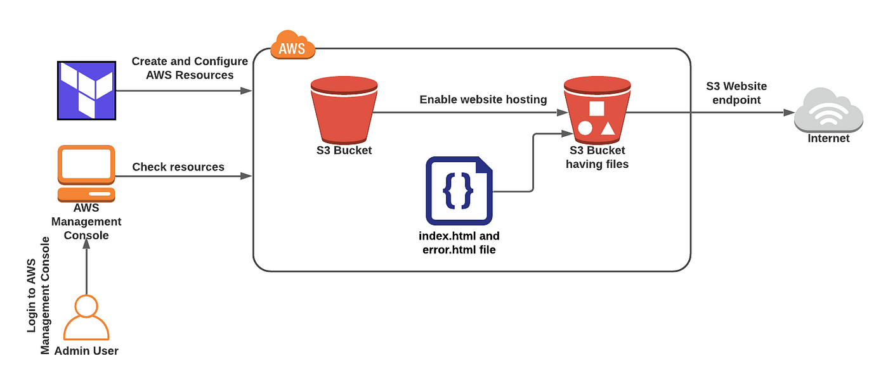

**Index.Html file**

<!DOCTYPE html>

<html lang="en">

<head>

<meta charset="UTF-8">

<meta name="viewport" content="width=device-width, initial-scale=1">

<title>Quote Generator</title>

<link rel="stylesheet" href="style.css">

</head>

<body>

<div class="container">

<h1>Quote Generator</h1>

<div id="quote-box">

<p id="quote"></p>

<p id="author"></p>

</div>

<button onclick="generateQuote()">New Quote</button>

</div>

<script src="script.js"></script>

</body>

</html>

**Output:**

**Style.css file:**

body {

  font-family: 'Segoe UI', sans-serif;

  display: flex;

  justify-content: center;

  align-items: center;

  height: 100vh;

  margin: 0;

  background: url("https://static.vecteezy.com/system/resources/previews/006/852/804/original/abstract-blue-background-simple-design-for-your-website-free-vector.jpg") center/cover no-repeat;

}

.container {

  text-align: center;

  background-color: white;

  padding: 40px;

  border-radius: 10px;

  box-shadow: 0 4px 15px rgba(0, 0, 0, 0.1);

}

#quote-box {

  margin: 20px 0;

}

#quote {

  font-size: 1.5em;

  margin-bottom: 10px;

}

#author {

  font-size: 1.2em;

  color: #555;

}

button {

  background-color: #007bff;

  color: white;

  border: none;

  padding: 10px 20px;

  font-size: 1em;

  border-radius: 5px;

  cursor: pointer;

}

button:hover {

  background-color: #0056b3;

}

**Output:**

**Script.js file:**

const quotes = [

{ text: "The only way to do great work is to love what you do.", author: "Steve Jobs" },

{ text: "Life is what happens when you're busy making other plans.", author: "John Lennon" },

{ text: "Success is not in what you have, but who you are.", author: "Bo Bennett" },

{ text: "Your time is limited, don't waste it living someone else's life.", author: "Steve Jobs" },

{ text: "Be yourself; everyone else is already taken.", author: "Oscar Wilde" },

{ text: "To be or not to be, that is the question.", author: "William Shakespeare"},

{ text: "Genius is one percent inspiration and ninety-nine percent perspiration.", author: "Thomas Edison"}

];

function generateQuote() {

const randomIndex = Math.floor(Math.random() * quotes.length);

const quote = quotes[randomIndex];

document.getElementById("quote").textContent = `"${quote.text}"`;

document.getElementById("author").textContent = `— ${quote.author}`;

}

**Output:**

**AWS Services**

**Step 1: Create an S3 Bucket**

Go to the AWS S3 console

Click "Create bucket"

Bucket name must be exactly the same as your domain name (hacksquad7)

Choose a region and create the bucket

**Step 2: Upload Website Files**

* Open the bucket
* Click **"Upload"**
* Upload your index.html, htmlimage.png, script.js,style.css files.

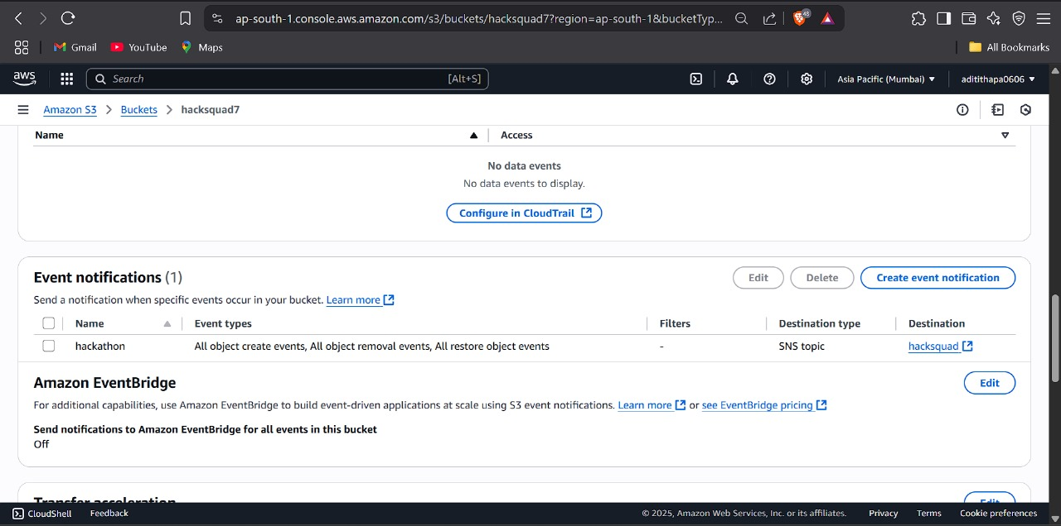

**Step 3: Enable Static Website Hosting**

Go to the **"Properties"** tab of the bucket

Scroll to **"Static website hosting"**

Click **Edit**, then: Choose: **Enable**

* A screenshot of a computer

  Description automatically generated

**Step 4: Make Files Public**

* Select all your uploaded files
* Click **Actions → Make public**  
  *(or use a bucket policy)*

**OR:**

Add this **bucket policy** under the **Permissions > Bucket policy** tab

* A screenshot of a computer

  Description automatically generated
* A screenshot of a computer

  Description automatically generated

**Step 5: Access Your Website**

* Go to **Properties > Static website hosting**
* Copy the **Website endpoint URL**
* Open it in a browser to see your site live

<http://hacksquad7.s3-website.ap-south-1.amazonaws.com>

* A screenshot of a computer

  Description automatically generated

Step 6 :Attach the SNS Topic to the S3 Bucket

* A screenshot of a computer

  Description automatically generated

**SNS Email Notification**:

**Step 1**: Create an SNS Topic

Go to Amazon SNS console

Click "**Topics**" → Create topic

Choose Standard

Name the topic (e.g., s3-upload-alerts)

Click Create topic

**Step 2**: Subscribe to the Topic

After creating the topic, click "Create subscription"

**Select:**

**Protocol**: Email (or another)

Endpoint: your email address (e.g., you@example.com)

Click Create subscription

Check your email and confirm the subscription

**Step 3:** Attach the SNS Topic to the S3 Bucket

Go to S3 Console

Open your target bucket

Click "**Properties**"

Scroll to Event notifications

Click "**Create event notification**"

Name the event (e.g., upload-event)

**Choose:**

Event types: e.g., All object create events

Prefix/Suffix: optional (e.g., only .jpg files)

Under Destination:

Choose SNS Topic

Select your topic (e.g., s3-upload-alerts)

Click Save changes

* A screenshot of a computer

  Description automatically generated

**Git & Github:**

Link: <https://github.com/dhadveomkar/Hackathon>